|  |  |  |  |  |  |  |  |  |  |  |  |  |  |  |  |  |  |  |  |
| --- | --- | --- | --- | --- | --- | --- | --- | --- | --- | --- | --- | --- | --- | --- | --- | --- | --- | --- | --- |
| Current State | | | | | | | | Input | | Next State | | | | | | | | Output | |
| Q0 | Q1 | Q2 | Q3 | Q4 | Q5 | Q6 | Q7 | Player_1_Wins | Player_2_Wins | D0 | D1 | D2 | D3 | D4 | D5 | D6 | D7 | O1 | O2 |
| X | X | X | X | 0 | 0 | 0 | 0 | 0 | 1 | X | X | X | X | 0 | 0 | 0 | 1 | 0 | 0 |
| X | X | X | X | 0 | 0 | 0 | 1 | 0 | 1 | X | X | X | X | 0 | 0 | 1 | 0 | 0 | 0 |
| X | X | X | X | 0 | 0 | 1 | 0 | 0 | 1 | X | X | X | X | 0 | 0 | 1 | 1 | 0 | 0 |
| X | X | X | X | 0 | 0 | 1 | 1 | 0 | 1 | X | X | X | X | 0 | 1 | 0 | 0 | 0 | 0 |
| X | X | X | X | 0 | 1 | 0 | 0 | 0 | 1 | X | X | X | X | 0 | 1 | 0 | 1 | 0 | 0 |
| X | X | X | X | 0 | 1 | 0 | 1 | 0 | 1 | X | X | X | X | 0 | 1 | 1 | 0 | 0 | 0 |
| 0 | 0 | 0 | X | 0 | 1 | 1 | 0 | X | X | 0 | 0 | 0 | 0 | 0 | 0 | 0 | 0 | 1 | 0 |
| 0 | 0 | 1 | X | 0 | 1 | 1 | 0 | X | X | 0 | 0 | 0 | 0 | 0 | 0 | 0 | 0 | 1 | 0 |
| 0 | 1 | 0 | 0 | 0 | 1 | 1 | 0 | X | X | 0 | 0 | 0 | 0 | 0 | 0 | 0 | 0 | 1 | 0 |
| 0 | 1 | 0 | 1 | 0 | 1 | 1 | 0 | 0 | 1 | 0 | 1 | 0 | 1 | 0 | 1 | 1 | 1 | 0 | 0 |
| 0 | 1 | 0 | 1 | 0 | 1 | 1 | 1 | X | X | 0 | 0 | 0 | 0 | 0 | 0 | 0 | 0 | 1 | 0 |
| 0 | 1 | 1 | 0 | 0 | 1 | 0 | 1 | 0 | 1 | 0 | 1 | 1 | 0 | 0 | 1 | 1 | 0 | 0 | 0 |
| 0 | 1 | 1 | 0 | 0 | 1 | 1 | 0 | 0 | 1 | 0 | 1 | 1 | 0 | 0 | 1 | 1 | 1 | 0 | 0 |
| 0 | 1 | 1 | 0 | 0 | 1 | 1 | 1 | 0 | 1 | 0 | 1 | 1 | 0 | 1 | 0 | 0 | 0 | 0 | 0 |
| 0 | 1 | 1 | 0 | 0 | 1 | 1 | 1 | X | X | 0 | 0 | 0 | 0 | 0 | 0 | 0 | 0 | 1 | 0 |
| 0 | 1 | 1 | 1 | 0 | 1 | 1 | 0 | 0 | 1 | 0 | 1 | 1 | 1 | 0 | 1 | 1 | 1 | 0 | 0 |
| 0 | 1 | 1 | 1 | 0 | 1 | 1 | 1 | 0 | 1 | 0 | 1 | 1 | 1 | 1 | 0 | 0 | 0 | 0 | 0 |
| 0 | 1 | 1 | 1 | 1 | 0 | 0 | 0 | 0 | 1 | 0 | 1 | 1 | 1 | 1 | 0 | 0 | 1 | 0 | 0 |
| 0 | 1 | 1 | 1 | 1 | 0 | 0 | 1 | X | X | 0 | 0 | 0 | 0 | 0 | 0 | 0 | 0 | 1 | 0 |
| 1 | 0 | 0 | 0 | 0 | 1 | 1 | 1 | 0 | 1 | 1 | 0 | 0 | 0 | 1 | 0 | 0 | 0 | 0 | 0 |
| 1 | 0 | 0 | 0 | 1 | 0 | 0 | 0 | 0 | 1 | 1 | 0 | 0 | 0 | 1 | 0 | 0 | 1 | 0 | 0 |
| 1 | 0 | 0 | 0 | 1 | 0 | 0 | 1 | X | X | 0 | 0 | 0 | 0 | 0 | 0 | 0 | 0 | 1 | 0 |
| 0 | 0 | 0 | 0 | X | X | X | X | 1 | 0 | 0 | 0 | 0 | 1 | X | X | X | X | 0 | 0 |
| 0 | 0 | 0 | 1 | X | X | X | X | 1 | 0 | 0 | 0 | 1 | 0 | X | X | X | X | 0 | 0 |
| 0 | 0 | 1 | 0 | X | X | X | X | 1 | 0 | 0 | 0 | 1 | 1 | X | X | X | X | 0 | 0 |
| 0 | 0 | 1 | 1 | X | X | X | X | 1 | 0 | 0 | 1 | 0 | 0 | X | X | X | X | 0 | 0 |
| 0 | 1 | 0 | 0 | X | X | X | X | 1 | 0 | 0 | 1 | 0 | 1 | X | X | X | X | 0 | 0 |
| 0 | 1 | 0 | 1 | X | X | X | X | 1 | 0 | 0 | 1 | 1 | 0 | X | X | X | X | 0 | 0 |
| 0 | 1 | 1 | 0 | 0 | 0 | 0 | X | X | X | 0 | 0 | 0 | 0 | 0 | 0 | 0 | 0 | 0 | 1 |
| 0 | 1 | 1 | 0 | 0 | 0 | 1 | X | X | X | 0 | 0 | 0 | 0 | 0 | 0 | 0 | 0 | 0 | 1 |
| 0 | 1 | 1 | 0 | 0 | 1 | 0 | 0 | X | X | 0 | 0 | 0 | 0 | 0 | 0 | 0 | 0 | 0 | 1 |
| 0 | 1 | 1 | 0 | 0 | 1 | 0 | 1 | 1 | 0 | 0 | 1 | 1 | 1 | 0 | 1 | 0 | 1 | 0 | 0 |
| 0 | 1 | 1 | 1 | 0 | 1 | 0 | 1 | X | X | 0 | 0 | 0 | 0 | 0 | 0 | 0 | 0 | 0 | 1 |
| 0 | 1 | 0 | 1 | 0 | 1 | 1 | 0 | 1 | 0 | 0 | 1 | 1 | 0 | 0 | 1 | 1 | 0 | 0 | 0 |
| 0 | 1 | 1 | 0 | 0 | 1 | 1 | 0 | 1 | 0 | 0 | 1 | 1 | 1 | 0 | 1 | 1 | 0 | 0 | 0 |
| 0 | 1 | 1 | 1 | 0 | 1 | 1 | 0 | 1 | 0 | 1 | 0 | 0 | 0 | 0 | 1 | 1 | 0 | 0 | 0 |
| 1 | 0 | 0 | 0 | 0 | 1 | 1 | 0 | X | X | 0 | 0 | 0 | 0 | 0 | 0 | 0 | 0 | 0 | 1 |
| 0 | 1 | 1 | 0 | 0 | 1 | 1 | 1 | 1 | 0 | 0 | 1 | 1 | 1 | 0 | 1 | 1 | 1 | 0 | 0 |
| 0 | 1 | 1 | 1 | 0 | 1 | 1 | 1 | 1 | 0 | 1 | 0 | 0 | 0 | 0 | 1 | 1 | 1 | 0 | 0 |
| 1 | 0 | 0 | 0 | 0 | 1 | 1 | 1 | 1 | 0 | 1 | 0 | 0 | 1 | 0 | 1 | 1 | 1 | 0 | 0 |
| 1 | 0 | 0 | 1 | 0 | 1 | 1 | 1 | X | X | 0 | 0 | 0 | 0 | 0 | 0 | 0 | 0 | 0 | 1 |
| 0 | 1 | 1 | 1 | 1 | 0 | 0 | 0 | 1 | 0 | 1 | 0 | 0 | 0 | 1 | 0 | 0 | 0 | 0 | 0 |
| 1 | 0 | 0 | 0 | 1 | 0 | 0 | 0 | 1 | 0 | 1 | 0 | 0 | 1 | 1 | 0 | 0 | 0 | 0 | 0 |
| 1 | 0 | 0 | 1 | 1 | 0 | 0 | 0 | X | X | 0 | 0 | 0 | 0 | 0 | 0 | 0 | 0 | 0 | 1 |

Game State Transition Table: Output a 2 when player 2 wins, a 1 when player 1 wins, a 0 all other times

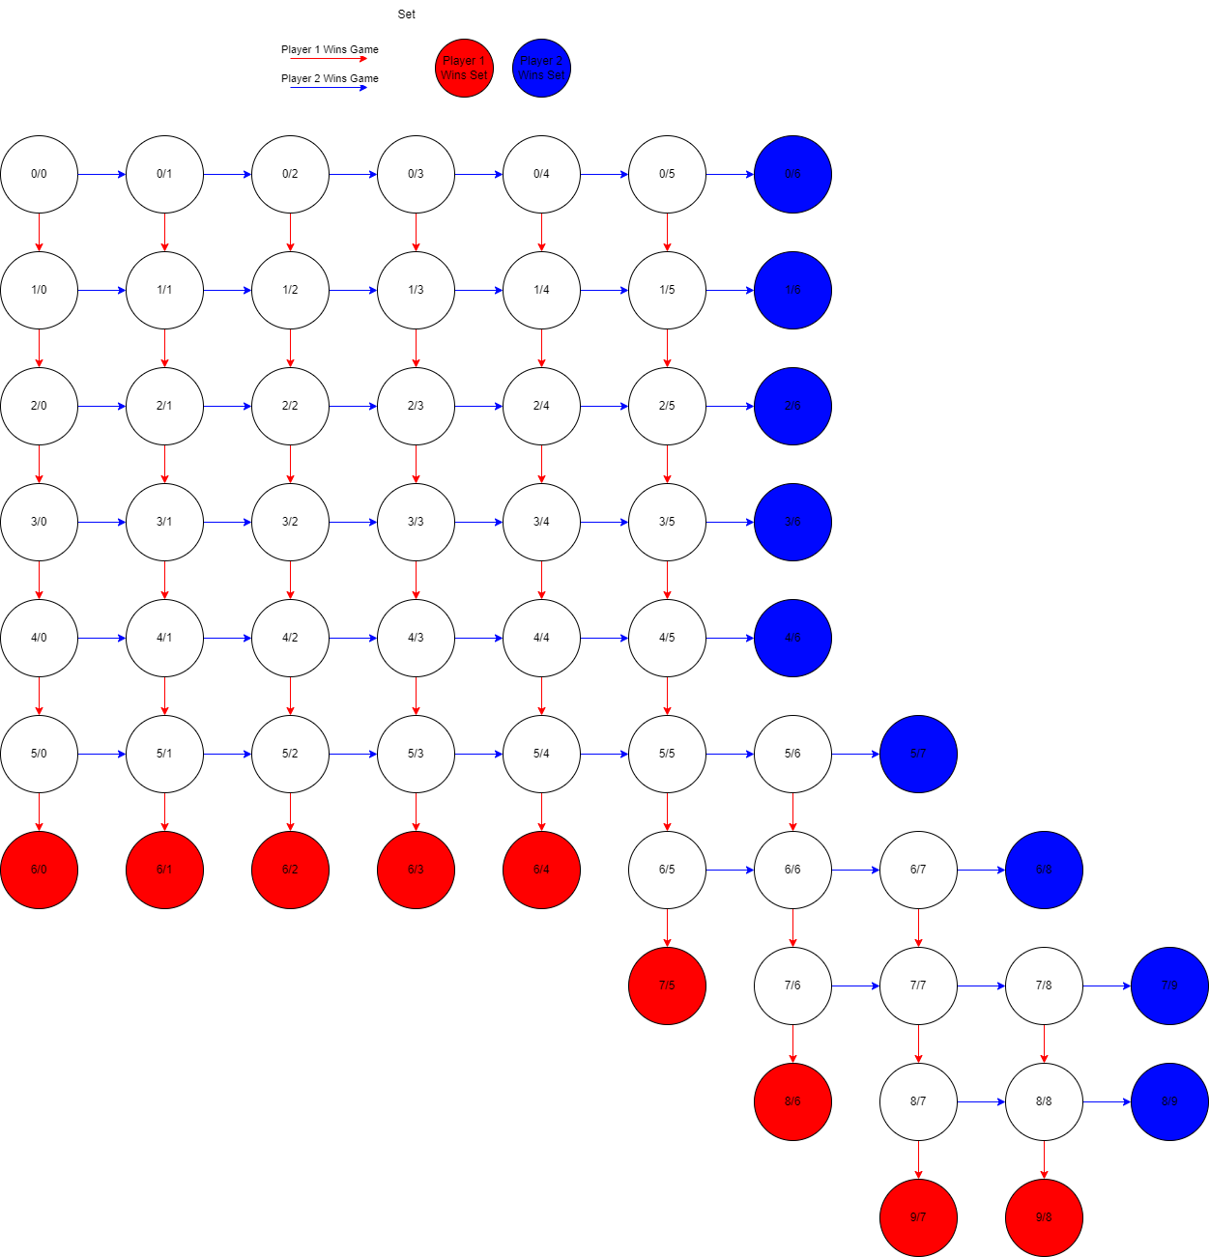

Q0-3\Q4-7

0000

0001

0010

0011

0100

0101

0110

0111

1000

1001

0000 0001 0010 0011 0100 0101 0110 0111 1000 1001

|  |  |  |  |  |  |  |  |  |  |  |  |
| --- | --- | --- | --- | --- | --- | --- | --- | --- | --- | --- | --- |
| Current State | | | | Input | | Next State | | | | Output | |
| Q0 | Q1 | Q2 | Q3 | Player_1_Wins | Player_2_Wins | D0 | D1 | D2 | D3 | O1 | O2 |
| 0 | X | 0 | 0 | 0 | 1 | 0 | X | 0 | 1 | 0 | 0 |
| 0 | X | 0 | 1 | 0 | 1 | 0 | X | 1 | 1 | 0 | 0 |
| 0 | X | 1 | 1 | X | X | 0 | 0 | 0 | 0 | 1 | 0 |
| 0 | 0 | 0 | X | 1 | 0 | 0 | 1 | 0 | X | 0 | 0 |
| 0 | 1 | 0 | X | 1 | 0 | 1 | 1 | 0 | X | 0 | 0 |
| 1 | 1 | 0 | X | X | X | 0 | 0 | 0 | 0 | 0 | 1 |

Set transition table: Output a 2 when player 2 wins, a 1 when player 1 wins, and a 0 all other times

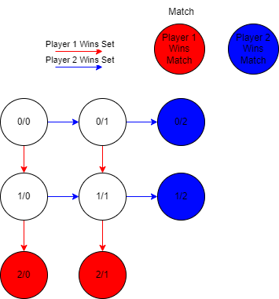

00 01 11

Q0Q1\Q2Q3

00

01

11

|  |  |  |  |  |  |  |  |  |  |  |  |  |  |  |  |
| --- | --- | --- | --- | --- | --- | --- | --- | --- | --- | --- | --- | --- | --- | --- | --- |
| Current State | | | | | | Input | | Next State | | | | | | Output | |
| Q0 | Q1 | Q2 | Q3 | Q4 | Q5 | Player_1_Wins | Player_2_Wins | D0 | D1 | D2 | D3 | D4 | D5 | O1 | O2 |
| 0 | X | X | 0 | 0 | 0 | 0 | 1 | 0 | X | X | 0 | 0 | 1 | 0 | 0 |
| 0 | X | X | 0 | 0 | 1 | 0 | 1 | 0 | X | X | 0 | 1 | 0 | 0 | 0 |
| 0 | X | X | 0 | 1 | 0 | 0 | 1 | 0 | X | X | 0 | 1 | 1 | 0 | 0 |
| 0 | 0 | X | 0 | 1 | 1 | 0 | 1 | 0 | 0 | X | 1 | 0 | 0 | 0 | 0 |
| 0 | 1 | X | 0 | 1 | 1 | 0 | 1 | 0 | 1 | X | 1 | 0 | 0 | 0 | 0 |
| 0 | 0 | X | 1 | 0 | 0 | X | X | 0 | 0 | 0 | 0 | 0 | 0 | 1 | 0 |
| 0 | 1 | 0 | 1 | 0 | 0 | X | X | 0 | 0 | 0 | 0 | 0 | 0 | 1 | 0 |
| 0 | 1 | 1 | 1 | 0 | 0 | 0 | 1 | 0 | 1 | 1 | 1 | 0 | 1 | 0 | 0 |
| 0 | 1 | 1 | 1 | 0 | 0 | 1 | 0 | 0 | 1 | 1 | 0 | 1 | 1 | 0 | 0 |
| 0 | 1 | 1 | 1 | 0 | 1 | X | X | 0 | 0 | 0 | 0 | 0 | 0 | 1 | 0 |
| 0 | 0 | 0 | 0 | X | X | 1 | 0 | 0 | 0 | 1 | 0 | X | X | 0 | 0 |
| 0 | 0 | 1 | 0 | X | X | 1 | 0 | 0 | 1 | 0 | 0 | X | X | 0 | 0 |
| 0 | 1 | 0 | 0 | X | X | 1 | 0 | 0 | 1 | 1 | 0 | X | X | 0 | 0 |
| 0 | 1 | 1 | 0 | X | X | 1 | 0 | 1 | 0 | 0 | 0 | X | X | 0 | 0 |
| 1 | 0 | 0 | 0 | 0 | X | X | X | 0 | 0 | 0 | 0 | 0 | 0 | 0 | 1 |
| 1 | 0 | 0 | 0 | 1 | 0 | X | X | 0 | 0 | 0 | 0 | 0 | 0 | 0 | 1 |
| 1 | 0 | 0 | 0 | 1 | 1 | 0 | 1 | 0 | 1 | 1 | 0 | 1 | 1 | 0 | 0 |
| 1 | 0 | 0 | 0 | 1 | 1 | 1 | 0 | 1 | 0 | 1 | 0 | 1 | 1 | 0 | 0 |
| 1 | 0 | 1 | 0 | 1 | 1 | X | X | 0 | 0 | 0 | 0 | 0 | 0 | 0 | 1 |

Game transition table: Output a 2 when player 2 wins, a 1 when player 1 wins, and a 0 all other times

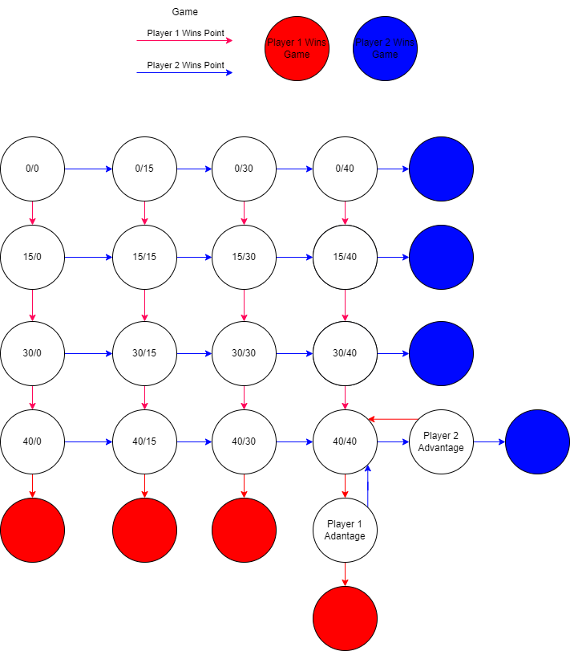

Q0-2\Q3-5

000

001

010

011

100

101

000 001 010 011 100 101